**Santec**

**PDL Scanning Test System Sample**

**Software manual**

2023-03-24



# Project Overview

This is an example software for a scanning test system for PDL measurements.

|  |  |
| --- | --- |
| development environment (computer) | Visual Studio 2015 |
| Framework framework version | 4.0 and its successors |
| Instrument.DLL | Version 2.5.1 |
| STSProcess.DLL | Version 2.2.2 |
| NI DLL | 15.5 and its successors |

# configure

instrumentation

1. Tunable Laser TSL Series (TSL-550/TSL-710/TSL-570/ TSL-770)
2. Power Meter MPM Series (MPM-210/210H/211/212/213/215)

This sample software allows you to control up to two MPM hosts (MPM-210 or MPM-210H).

1. Polarization Controller PCU Series (PCU-100/PCU-110)

Communication settings

Tunable Laser (TSL) Control TSL-550/710: GPIB

TSL-570/ TSL-770: GPIB, TCP/IP, USB

* It can be changed on the source code. The initial value of the separator is CRLF.

Power Meter (MPM) Controls

MPM-210/210H: GPIB, TCP/IP and USB

Polarization Controller (PCU) Controls

PCU-100: GPIB

PCU-110: GPIB, TCP/IP and USB

connecting reference

Use a BNC cable to connect the following parts. The following sections are connected using the

PCU-110

|  |  |
| --- | --- |
| TSL-*** Trigger Output -> | MPM-210H Trigger Input |
| PCU-110 Power Monitor ->    If PCU-100 | MPM-210H TSL Monitor |
| TSL-*** Trigger Output -> | PCU-100 Trigger Input |
| PCU-100 Trigger Output -> | MPM-210H Trigger Input |

If PCU-110

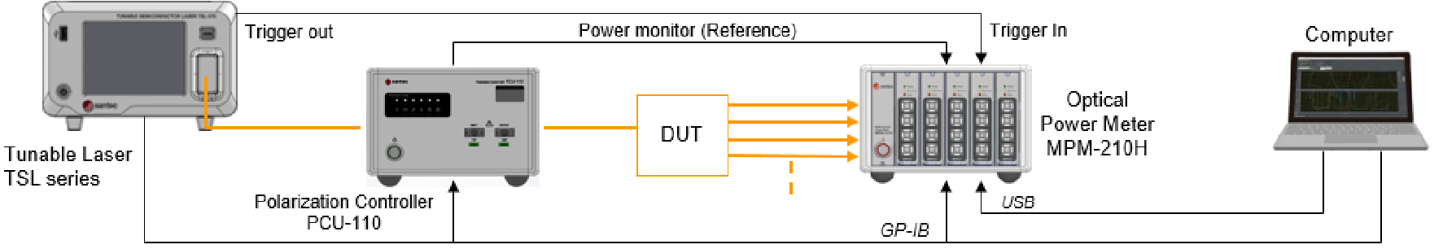

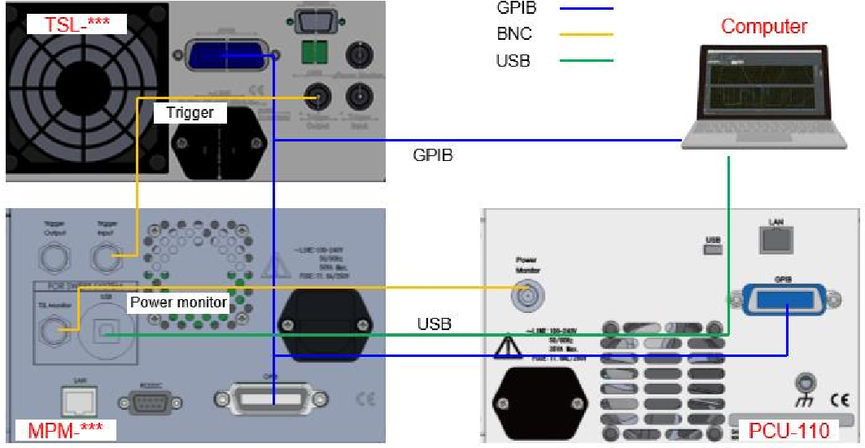

If PCU-100

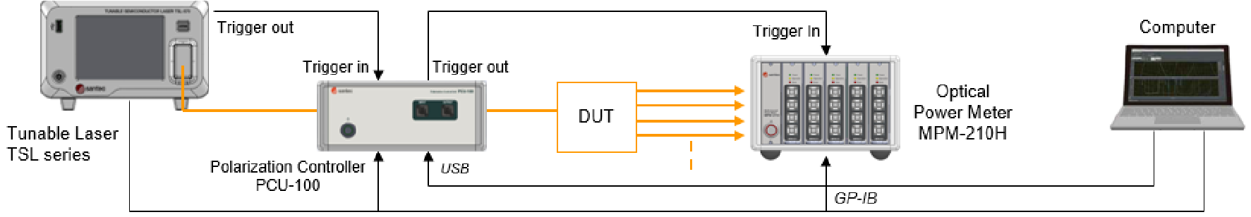

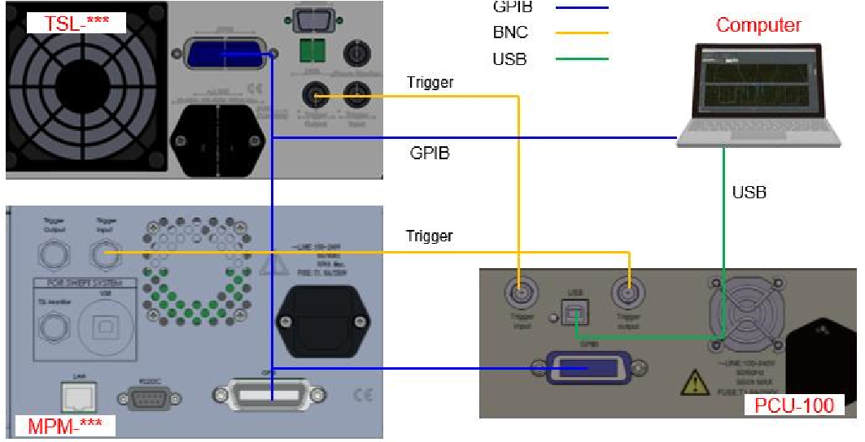

Figure 1. Connected configuration

# procedure

1. Instrument Settings Window

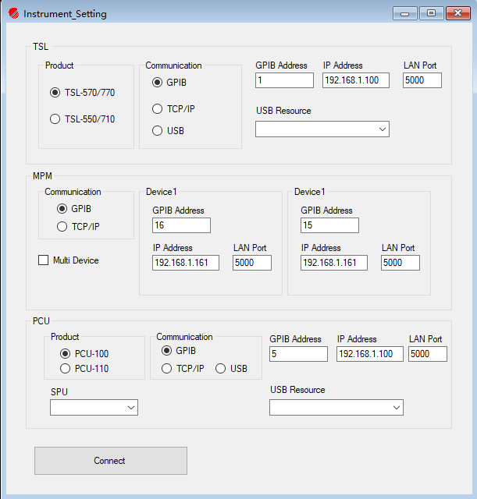

Figure 2. Instrument Setup Window

1. Functions - Instrument Settings   
    screen is used from the main window at startup. Expands each instrument's settings to the main window.
   1. Form Load

The SPU (DAQ) device number and USB resource (when the TSL-570 interface and PCU-110 interface are USB) connected to the PC are received from the main form and displayed in each Combobox control

* 1. TSL

Displaying TSL Communication Setup Information

* 1. MPM

Displays information about the MPM's communication settings for up to two hosts

* 1. PCU

Displaying PCU communication setting information

* 1. SPU

Displays the device number of the DAQ.

* 1. Connect

After setting up each measuring instrument in Figure 2, press the "Connect" button and the STS PDL Demo software interface is shown in Figure 3.

1. STS PDL Example Software Window



K. each channel individually

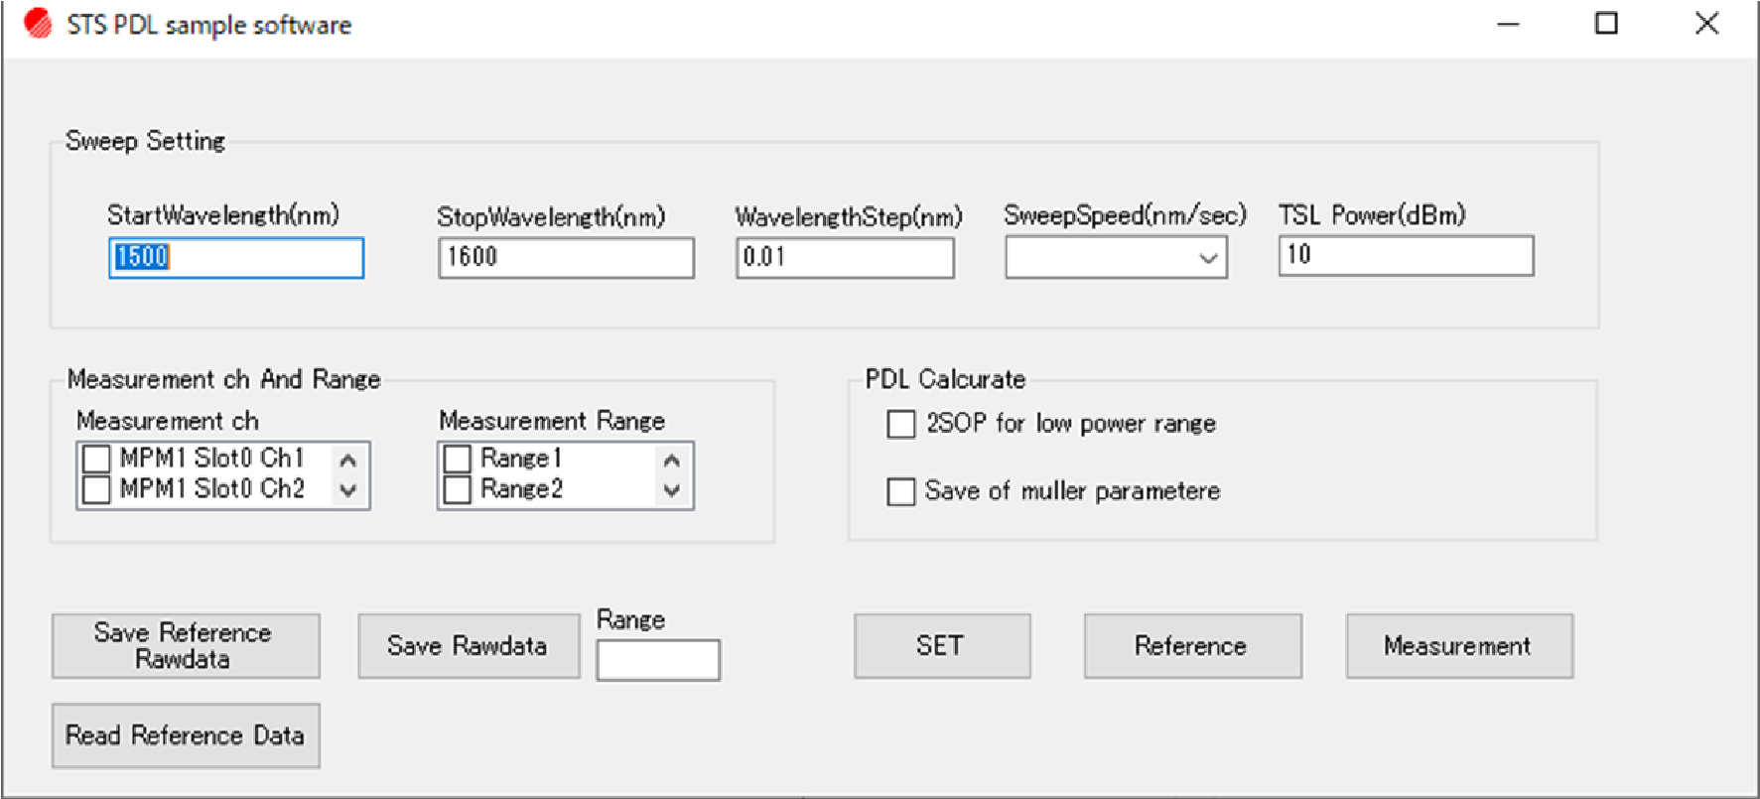

A.

Sweep

condition

set

t

ing

B. Sweep condition set

C. Reference

D. PDL

m

easurement

G.

Set Measure

ment

Range

F.

Set

Measurement ch

H.

Read

Reference data

I.

Save

Reference Rawdata

J.

Save

Rawdata

E. PDL

condition setting

Figure 3. PDL Example Software Window

1. How to use
   1. Tunable Laser Settings  
       Enter scanning conditions in the Scan Setup (A) frame

|  |  |  |
| --- | --- | --- |
| Starting wavelength (nm) | starting wavelength |  |
| Stop Wavelength(nm) | Stop Wavelength |  |
| Step wavelength(nm) | Measurement data step wavelength |  |
| Scanning speed (nm/s) | scanning speed |  |
| TSL Power (dBm) | TSL Output Power |  |

* 1. Power Meter Settings  
      Set up Measurement ch (F) and Measurement Range (G) in the Measurement Channels and Ranges frame. Set the channels of the power meter module at Measurement ch (F). When multiple channels are selected, multiple devices on the channel under test (DUT) can be measured simultaneously. Set the range for each scan at Measurement Range (G). When multiple ranges are selected, high dynamic range measurements can be performed. This function is effective when the dynamic range of the DUT is 40 dB or higher. A dynamic range of about 40 dB can be measured per scan.  
      Under the following conditions, the dynamic range of the DUT is set to 60 dB, the output power of the light source is set to 8 dBm, and the DUT is connected directly without the need to insert a splitter between the tunable devices laser (TSL) and power meter (MPM).

Range number: 2

1st Range: Range 1

2nd Range: Range 4

3. Set the set parameters  to each instrument The set parameters are set to each instrument when the "SET(B)" button is clicked. The set parameters are passed to each instrument class and STS Process class. The STS data structure required to retain data in the STS Process is also set.

(TSL setting) Power setting: TSL class, Set_APC_Power_dBm() Sweep parameter setting: TSL class Set_Sweep_Parameter_for_STS() Set "Sweep start", "Sweep stop", "Sweep Speed", "Trigger Step", "Trigger output mode(). Sweep stop", "Sweep Speed", "Trigger Step", "Trigger output mode( Step) " , "Start Mode(Trigger Standby)", "Sweep mode(one way continuous)", and "Sweep times(one scan)". As for the trigger step, the minimum trigger step is set by the Sweep Speed parameter and returned as the actual step. When using the TSL-570, set the trigger source (wavelength constant), trigger input voltage polarity (rising edge), trigger output voltage polarity (rising edge), and trigger pass (disabled).

(MPM settings)

Logging Parameter Setting: the MPM class, Set_Logging_Parameter_for_STS() sets the averaging time, sampling point, and logging mode ((Freerun)) from the self-variable parameters. The set averaging time can be obtained from the MPM class Get_Averagin_Time().

(SPU settings)

Record parameter setting: SPU class, Set_Sampling_Parameter() sets the sampling time from the independent variable parameter. The 4th parameter specifies the actual step size returned by Set_Sweep_Parameter_for_STS() when setting TSL.

(PCU settings)

Power Range Adjust: PCU class, use Range_Adjust() to set the power range. This function is called to adjust the input range to the PCU after setting the power to the TSL.

(STS process setup)

Rescaling parameter setting: PDLSTS class, Set_Rescaling_Setting()

Create a list of scanned wavelengths: PDLSTS class, Make_Sweep_Wavelength_Table() *1

*1: Rescaling based on this table. The third parameter specifies the actual step size returned by Set_Sweep_Parameter_for_STS() when setting the TSL.

Creates a rescaled wavelength table:

PDLSTS class, Make_Target_Wavelength_Table() *2

*2: This is the wavelength table after the scanning test system has readjusted the output.

Since measurement data is associated with information such as

Measurement range and ch, prepare data information structure STS Data Struct for passing data for measurement. (Prepare_DataST function)

1. Reference Test of data When Reference (C) is clicked, each polarization state is scanned and Reference data is acquired under setting conditions 1 and 2. The order of polarization state settings is Vertical → Horizontal → Linear 45° → Right-hand circular. When multiple channels are selected and each channel individually(K) is selected, data is acquired and used for each channel individually in Reference (C). * When multiple power measurement ranges are set, reference data can be obtained for the first range.
2. Setting of calculation processing methods

PDL Calcurate (E) allows you to set the processing method and data storage conditions during PDL measurements (Measurement (D)). When measuring multiple ranges, if "2SOP for low power range" is selected and a PDL measurement is performed, only the lower ranges other than range 1 are scanned vertically and horizontally. If PDL measurement is performed without selection, 4 polarization state measurements are performed in all ranges. If "Save of Mueller parameter" is selected and a PDL measurement is performed  , the Mueller parameters m11, m12, m13 and m14 calculated from the tested 4-polarized state data are exported in addition to the normal PDL in a separate file when the data is saved.

m11 = (Horizontal + Vertical)/2

m12 = (Horizontal-Vertical)/2

m13 = Linear 45° - m11

m14 = Right-hand circular - m11

The above is the output information. The unit is mW, but negative values may be output due to subtraction.

1. PDL measurements

When Measurement (D) is clicked, the PDL performs measurement under the conditions set in 1 and 2. If multiple power measurement ranges are set, Sweep processing is executed with the number of ranges set, and data merging processing is executed in the STS Process class. After that, IL data is calculated for each polarization → PDL calculation is executed and the result is output to a file. After one measurement of the data is completed, call the TSL class Sweep_Stop() to cancel the TSL Sweep process (trigger standby state) . (Note: The MFC version of the software selects the path to the stored data file before scanning begins, and other versions of the software select the path to the stored data file after scanning is complete ) Note) When a new scan parameter is set without executing the process, the TSL will have no parameters. For more information about scan processing, see 4).

1. Preserving Reference Raw Data

After clicking Save Reference Rawdata (I), the STS Data Struct is specified when reading Reference Rawdata from the STS Process class. The saved data is saved in csv format in the specified path. The results of Vertical polarized light, Horizontal polarized light, Linear +45 ° polarized light and Right-hand circular polarized light are saved in separate files. When multiple channels are selected and each channel individually(K) is checked, the monitordata for each channel is saved individually. (Note: MFC version of the software for easy processing, and other versions of the use of different is only need to select a path, in the internal processing will be added to the path suffix polarization state name automatically save the file, at this time you can not change the name of the file, otherwise in the Reference data will be read in the error will occur. (Other versions of the software need to choose their own path for each file).

1. Preservation of raw data

When you click Save Rawdata ( (J), the measurement data at Measurement (D) is read from the STS Process class. Specify that the STS Data Struct and Rawdata are saved in the specified path of the csv file. For each range and SOP, the data will be output to a different csv file. The range is specified in the text box next to the "Save Rawdata" button (J). If the entered range is invalid, an error message will be displayed.

1. Reading Reference data

Read the Reference data saved in 7. and pass it to the STS Process class. Specify the Reference file in the order of Vertical polarized light, Horizontal polarized light, Linear +45 ° polarized light and Right-hand circular polarized light. If a reference file other than the one set by the SET button is read, an error message is displayed. When multiple channels are selected and EACH channel individually(K) is checked, reading requires each channel to have its own monitordata data. (Note: MFC version of the software for easy processing, and other versions of the use of different is only need to select a path, in the internal processing will be added to the path suffix polarization state name automatically read the file. (Other versions of the software need to choose their own path to read each)

5) Scanning Steps

1. Set TSL as the scanning start wavelength and set the power measurement range of MPM.

2. Set the PCU to the corresponding polarization state.

3. Start TSL scanning and set TSL to Trigger Signal Input Standby mode. *1

4. MPM started recording .

5. SPU started recording .

6. Software trigger for issuing TSLs.

7. Query the operation completion status of MPM and SPU. *2

8. Wait for the TSL scan to complete.

9. Set the TSL to the scanning start wavelength .

10. Execute the TSL class Sweep_Start() for the next measurement and start TSL Sweep.

11. Read measurement data from MPM and SPU and these data and STS Data Struct to STS Process class.

*\*1*

When performing multi-range measurements in PDL measurement, multiple scans are required to acquire one data. For the first scan of one data, the TSL class Sweep_Start() is called to start the TSL scan with the trigger standby state set to the start wavelength before scanning is processed. The TSL trigger standby setting (SweepStartMode setting) is performed in the "SET" button.

*2

MPM runs in FreerunMode. If there is no trigger signal input from the TSL, the MPM measurement will not start. In this example software, the Sweep_Process() function, which performs the Sweep processing, is coded to return -9999 as an error if the MPM measurement has not completed after a sample time of +2000 milliseconds.

6) Scanning Steps

PDL calculations use 4-polarization IL data. Perform Rescaling processing and IL calculation processing before performing PDL processing.

1. Acquisition of target wavelength list

PDLSTS class Get_target_Wavelength_Table()

1. PCU wavelength sensitivity data acquisition PCU class Cal_All_SOP_Paremter()

The wavelength table obtained in 1 is entered as a variable, and the calibration data calculated in the second variable is returned as a 3-dimensional array.

1. Increase PCU wavelength sensitivity

PDLSTS class Add_PCU_CalData()

Pass the calibration data obtained in 2 to the PDLSTS class.

1. IL Access to data

PDLSTS Class Get_IL_Merge_Data ()

Get_IL_Merge_Data. Get_IL_Merge_Data is called when merging multiple range data.

1. PDL calculations

PDLSTS Class Cal_PDL()

Pass the IL data for the 4 polarization states obtained in 4 to the Cal_PDL function and perform the PDL calculation.

The data to be passed is a two-dimensional array (SOPindex, Wavelengthindex).

Please enter the SOPindex in the following order.

0: Vertical, 1: Horizontal, 2: Linear 45°, 3: Right-hand circular

Note that if this order is different, the calculation may not be performed correctly. The results of the calculation are returned with the parameters 2 (PDL), 3 (IL), 4 (Ilmax), and 5 (ILmin). This function is a PDL calculation for each channel. When calculating multiple channels, pass the IL data for each corresponding channel and perform the procedure.